11/01
- Select case from publicly available data.
  - Focus more on dilemma and not on solution
12/20
- Need to have consent before publishing case
- If consent not available then write based off “secondary sources”
  - Secondary sources is when data and information is already available for public reference or public domain
- Make sure the case is relevant (< 5 yrs); publishers decide what is relevant
- Make sure your case answers the 5 W’s (why, what, where, when, whom)
- The idea is not to convince everyone about your solution/ teach everyone your soln, it is about learning how is a decision arrived at to generate multiple solutions
  - Are the solutions sustainable?
- Case Idea suggested by Dr. Kakoli (She’ll help with it if need be) - Tesla board versus Elon Musk;
  - We will be focusing on Boards effectiveness? How do we ensure that governance is managed better than this way
- 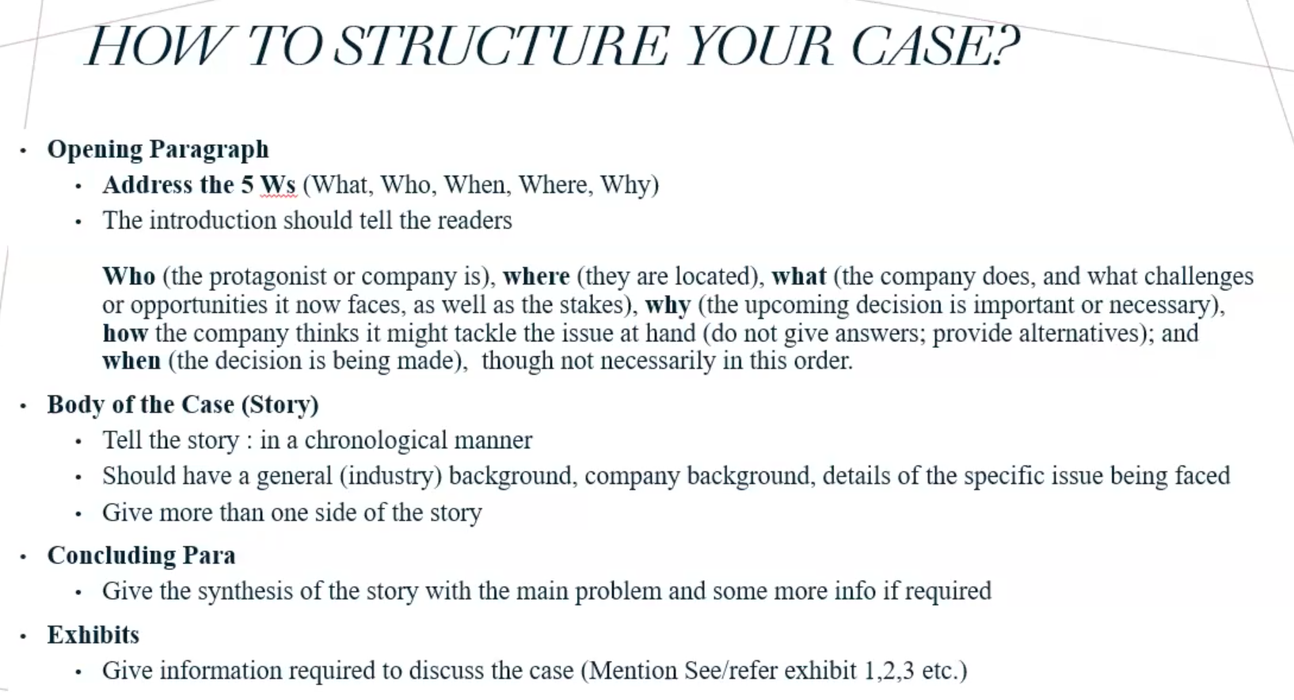
- Different publishers have different guidelines; necessary to follow the publisher guidelines before submitting
  - When case is reviewed, it is scrutinized. Refer to the class .ppt for example. 4 pages of feedback
- Only Case Study is for students, Teaching Note is for self (whoever teaches the case). Through classroom discussion teacher should guide students in the direction of the teaching note
- Research Methods and Data Collection in Case Writing
  - Two ways to collect data:
    - Quantitative
    - Qualitative
    - 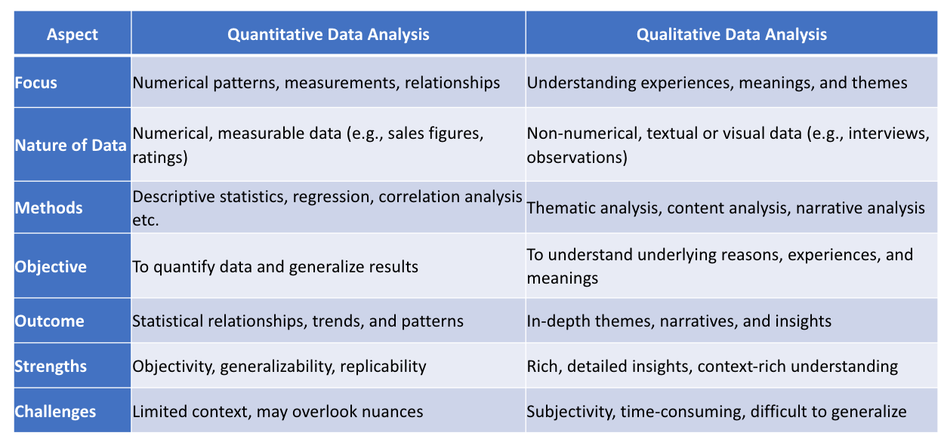
  - Very important to cite sources and relevant study material
    - How to cite? Refer to the specific publishers(Ivey, Emerald, Sage etc) guideline
01/09:
- Collect as much information as possible for your case. Later you can choose what to use for your case and what not.
- Refer to the “Teaching Note Template” that was presented in class
- Case Study is Dilemma focused; Teaching Note is Solutions Oriented and how to execute those solutions.

